

WINNER OF THE 2024 DIVERSITY, EQUITY AND INCLUSION POSTER CONTEST!

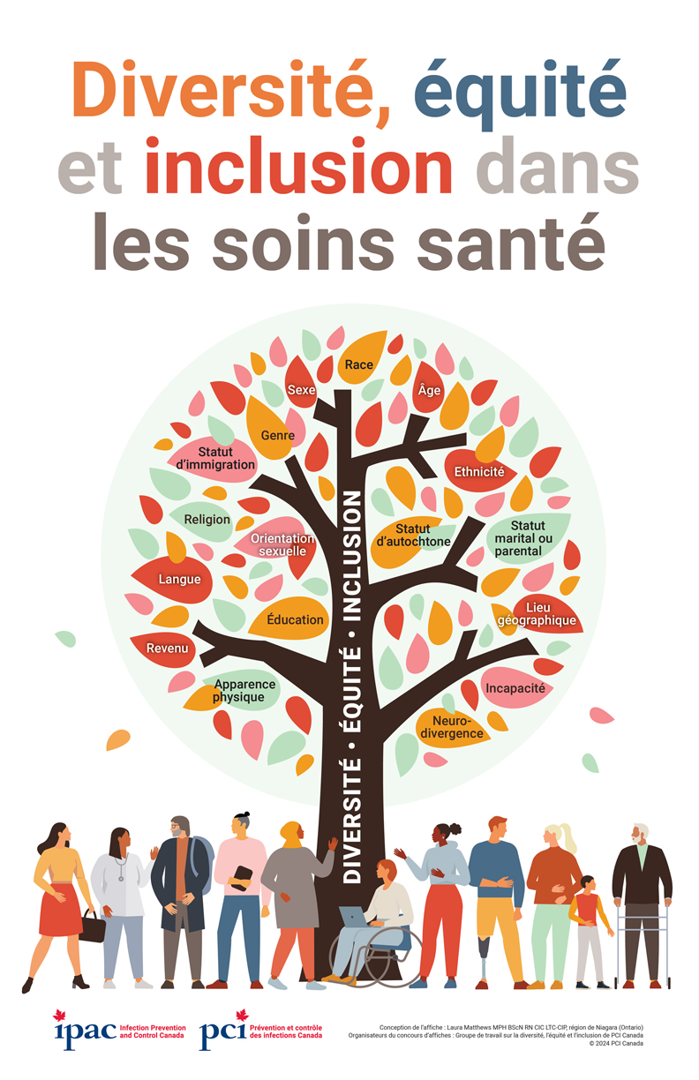

The winning poster, created by Laura Matthews, is available for downloading and printing from the IPAC Canada DEI webpage (https://ipac-canada.org/diversity-equity-and-inclusion)

If you are interested in purchasing the 2024 poster in bulk, please complete the following order form and fax or email it to IPAC Canada.

IPAC Canada
Fax: 1-204-488-5028
Telephone: 1-866-999-7111
info@ipac-canada.org
http://www.ipac-canada.org
2024 DEI POSTER
ORDER FORM

Poster  11”x17” | Order A | Fee (before s&h and GST/HST) | Order B | Fee (before s&h and GST/HST) | Order C | Fee (before s&h and GST/HST) | Order D | Fee (before s&h and GST/HST) | Order E | Fee (before s&h and GST/HST)
Single sided/English only | A. 50 | $87.50 | B. 100 | $150 | C. 150 | $175 | D. 200 | $200 | E.. 500 | $375
 |  |  |  |  |  |  |  |  | Over 500 | Call for quote

ORDER INFORMATION

Number of posters _____
Fee $ _____________

*Shipping & handling, add 15% $ _____________

SUB-TOTAL $ _____________

GST/HST on purchase including S&H – NB/NS/NL/PE (add 15%), BC/AB/SK/MB// /Territories (add 5%), ON (add 13%); QC (add 14.97%)
BN118833201RT0001 $ _____________
TOTAL FEE ENCLOSED $ _____________

Posters will be delivered to one address only.
I AM PAYING BY
□Cheque, payable to IPAC Canada □VISA, MasterCard or AMEX □VISA Debit
____ ____ ____ ____ ____ ____ ____ ____ ____ ____ ____ ____ ____ ____ ____ ____
Credit Card Number
Expiry ____ ____ Security Code (from back of card) ___ ___ ___
Name on Card ______________________________________________________________
Signature of Cardholder ______________________________________________________
SHIP TO (Street address only – courier will not deliver to post office box number)

_________________________________________________________________
Name of Contact
_________________________________________________________________
Facility Name
__________________________________________________________________
Street address
_________________________________________________________________
City, Province, Postal Code
_________________________________________________________________
Telephone number of contact

