Long-Term Care Exercise
You will need:
Appendix A_LTC Surveillance Database, available on the IPAC Canada webpage for download (blank), screenshot for the purposes of this exercise provided on page 5.
Resident Respiratory Tract Infection Line List on pages 6-7.
Resident Dining Room Seating Arrangement on page 8.
Surveillance Definitions of Infections in Canadian Long Term Care Facilities, available on the IPAC Canada webpage. Relevant excerpts are provided on page 9.

Questions:
1. Data cleaning
Review the Appendix A_LTC Surveillance Database and list 2 data errors. How would you correct them?
Carly Carrot is listed twice in rows 7 and 16. Peter Pear has a missing symptom onset date. Remember to make changes to your data set only once you’ve confirmed the correct information by returning to the resident’s chart or other valid source of information. Make the necessary changes to Appendix A; assume that Peter’s symptoms started on October 3.

2. Applying case definitions
You are an ICP at a long-term care home (ABC Care) and have been asked to review the resident line list on pages 6-7 to determine whether any of the residents meet the IPAC Canada surveillance definitions, on page 9, for common cold, influenza-like illness or pnuemonia respiratory infections.
Which resident(s) meet the case definition for a common cold/pharyngitis?

Carly Carrot: cough, nasal congestion, chills, headache (could meet cold and ILI definition; in such a case this should trigger additional symptom monitoring and possibliy collection of an NP swab)
Petunia Pea: fever, nasal congestion, sore throat (insufficient symtpms for ILI definition)
Adam Apple: runny nose/sneezing, nasal congestion (symptoms match cold definition)
Aaron Asparagus: cough, runny nose/sneezing, loss of appetite (symptoms match cold definition)

Which resident(s) meet the case definition for influenza-like illness (ILI)?
Bella Banana: fever, cough, sore throat, chills (best matches symptoms for ILI definition)
Cam Cabbage: fever, cough, chills, headache (best matches symptoms for ILI definition)

Which resident(s) meet the case definition for pneumonia?

Tommy Tomato: fever, cough, runny nose, chills, x-ray confirming pneumonia
Liam Lettuce: fever, productive cough, sore throat, chills, body aches, x-ray confirming pneumonia
Polly Pumpkin: productive cough, sore throat, malaise, headach, loss of appetie, x-ray confirming pneumonia
Peter Pear: cough, x-ray confirming pneumonia
3. Epi-curve
Study the October 2022 respiratory tract infection line list on pages 6-7. Manually plot the onset dates for all infections cases against the number of cases observed on each date to generate an epi-curve.

4. Rate calculations
It is the end of the month and you are reviewing respiratory tract infection surveillance data from October. Your observations include:
- There were 150 residents present in the facility for the full month of October
- A total of 12 residents had new onset of influenza-like illness in the month of October
- A total of 7 residents developed a common cold in the month of October

Hint: Rate = (X/Y)*k
What is the total number of resident days for the month of October?
150 residents x 31 days in October = 4,650 resident days

What is the incidence rate of ILI for the month of October per 1,000 resident days?
(12 cases of ILI / 4,650 resident days) x 1,000 = 2.6 cases of ILI per 1,000 resident days

What is the prevalence rate of common cold in the month of October per 100 residents?
(7 residents with a cold / 150 residents) x 100 residents = 4.7 cases of cold per 100 residents
5. Examining epi links - Floor plan
Examine the dining room floor plan on page 8. Compare this to the resident line list on pages 6-7. What do you notice?
The illness started at Tommy Tomato’s table and spread outward to those in proximity.

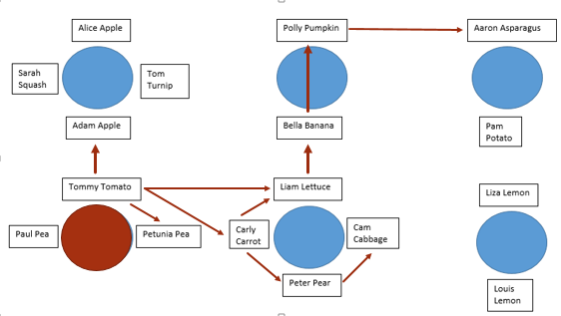

6. Data to action
What are the next steps you would take based on your observations? Consider if further investigation is needed, if infection prevetion and control interventions are warranted, etc.
Investigate adherence to key elements associated with Routine Practices and Additional Precautions

7. Reviewing annual data

The graph above depicts a summary of all the infections in your facility over the past year. You have been asked to prepare an annual summary report for unit nursing staff and administrations, what information would you choose to highlight and what images/visuals would you consider including?

Of note is the spike in respiratory infections in October and November. An increase in UTIs in March, skin infections in January and December, and eye infections in May, June and August can also be seen. A histography like the one depicted is useful in conveying a large amount of information. Consider your audience when determining the most appropriate way to present surveillance data.

8. Benchmarking
To further understand the observed increase in respiratory illness in your facility in the fall of 2022, and whether this was unusual for your facility, your manager has asked you to internally benchmark your data. Which of the following is most appropriate:
- Comparing the data for 2022 to 2021 (full year)
- Comparing the data from October-December of 2022 (fall) to January-March of 2022 (spring)
- Comparing data from October-December of 2022 (fall) to the same time period in 2021
It can be useful to visualize trends over time (A and B), but in this case the most appropriate benchmark is to examine the same period during recent respiratory seasons (C).

Appendix A – LTC Surveillance Database (screenshot) (back to Q1a)
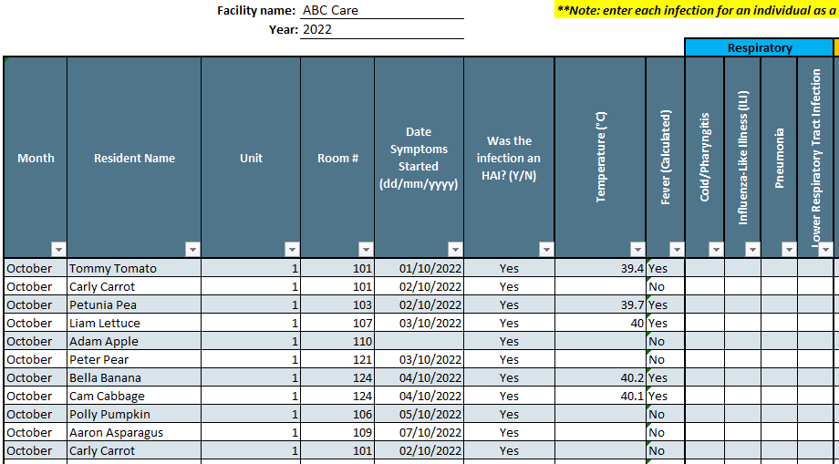

Resident Respiratory Infection Line List without Infections Identified (back to Q1b, Q1c or Q1e)

(line list continues below)

LTC Facility Dining Room Floor Plan (back to Q1e)
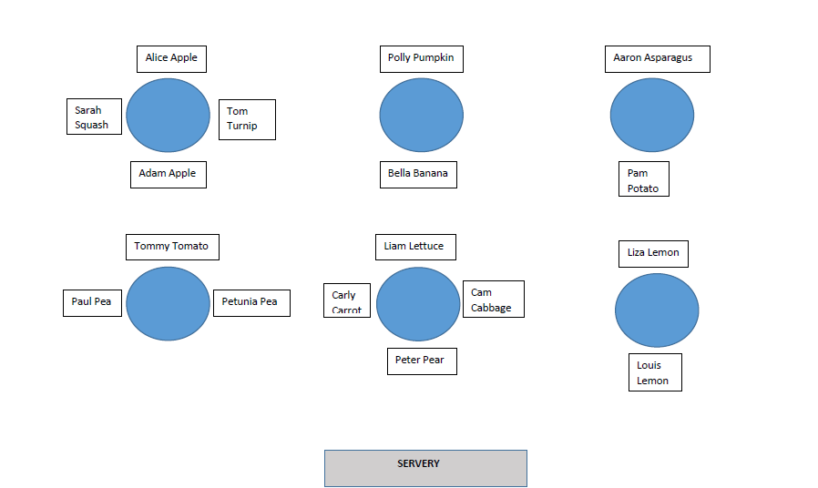

IPAC Canada Long-Term Care Infection Surveillance Definitions Excerpt (back to Q1b)

Resident Respiratory Infection Line List with Infections Identified (back to Q1b)

(line list continues

